
Company
Logotype

Cone Beam Computed Tomography- Report



Porur Dental X-rays & CBCT

Patient Name : Mrs. Shanthi | Date of Report : 23.10.2024
Age/ Gender : 52 years/ Female | Region of Interest : CBCT Full Skull
Referring doctor: Dr. Lokesh | Indication : Implant assessment
Clinical Notes: Nil
PATIENT INFORMATION

CBCT- Full Skull provided
CBCT – IMAGE DETAILS

RADIOGRAPHIC INTERPRETATION

- Complete loss of crown and root structure in relation to 13, 14, 16, 17, 18, 23, 24, 28, 38, 46, 48.
- Root stumps in relation to 26, 27, 35, 45.
- Fractured crown: 36.
- Presence of hyperdense restorative material within the pulp canals of 43, 44 is evident.
- The alveolar ridge in relation to the maxillary and mandibular alveolar ridge is present with normal trabecular pattern.

IMPLANT ASSESSMENT

 | 11 region | 12 region | 13 region | 14 region | 21 region | 22 region | 23 region | 24 region
Sub-Crestal | 5.8 | 4 | 2.9 | 3.2 | 3.7 | 2.8 | 3.6 | 3.3
Mid- Crestal | 4.7 | 3.6 | 3.9 | 4.2 | 3.7 | 2.9 | 3.5 | 3.9
Distance between the alveolar ridge and Floor of the Nasal cavity (in mm) | 18 | 11.6 | 19.1 | 19.4 | 13.1 | 12.5 | 18.1 | 17.8

 | 15 region | 16 region | 17 region | 25 region | 26 region | 27 region
Sub-Crestal (in mm) | 5.6 | 5.3 | 6.4 | 5.2 | 5.3 | 8.8
Mid- Crestal (in mm) | 5.6 | 7.2 | 7.5 | 4.7 | 6.9 | -
Distance between the alveolar ridge and floor of the maxillary sinus (in mm) | 12.6 | 8.2 | 6.6 | 9 | 7.1 | 3.5

 | 31 region | 32 region | 33 region | 34 region
Sub-Crestal (in mm) | 3.5 | 3.7 | 5.6 | 6.1
Mid- Crestal (in mm) | 4.3 | 4.8 | 6.1 | 6.4
Distance between alveolar ridge and the inferior border of mandible (in mm) | 20.1 | 20.1 | 17.8 | 20.8

 | 41 region | 42 region | 43 region | 44 region
Sub-Crestal (in mm) | 3.3 | 4.6 | 5.5 | 4.3
Mid- Crestal (in mm) | 5.1 | 4.9 | 5.7 | 5.6
Distance between alveolar ridge and the inferior border of mandible (in mm) | 18.7 | 20.8 | 19.1 | 25.1
 | 45 region | 46 region | 47 region
Sub-Crestal (in mm) | 8 | 5.8 | 9.4
Mid- Crestal (in mm) | 7.2 | 5.6 | 9.6
Distance between alveolar ridge and the inferior alveolar nerve canal (in mm) | 14.8 | 14.8 | 8.3
Distance between alveolar ridge and the inferior border of mandible (in mm) | 23.4 | 25.3 | 17.6

 | 35 region | 36 region | 37 region
Sub-Crestal (in mm) | 6.3 | 8.4 | 9.2
Mid- Crestal (in mm) | 6.7 | 8.9 | 10
Distance between alveolar ridge and the inferior alveolar nerve canal (in mm) | 12.8 | 12.9 | 10.2
Distance between alveolar ridge and the inferior border of mandible (in mm) | 24.5 | 21.3 | 17.2

RADIOGRAPHIC IMPRESSION

- Partially edentulous maxillary and mandibular arch.
- Root stumps in relation to 26, 27, 35, 45.
- Fractured crown: 36.
- Root canal treated teeth: 43, 44.

Kindly correlate with clinical findings


IMAGES FOR REFERENCE

RECONSTRUCTED PANORAMIC VIEW

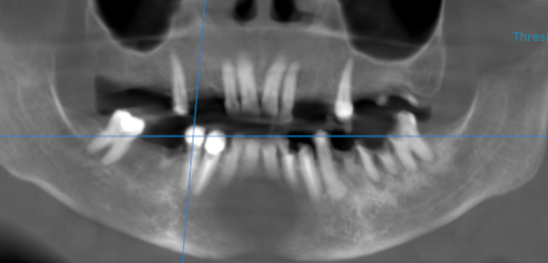

3-DIMENSIONAL VIEW

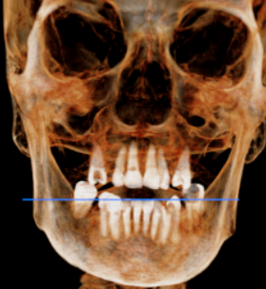

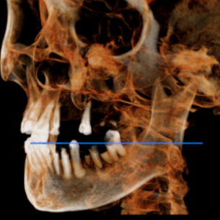
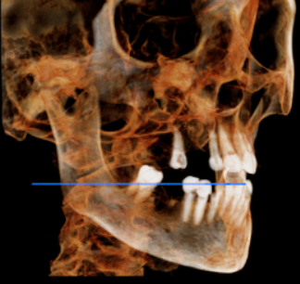

CROSS SECTIONAL VIEW

11 region | 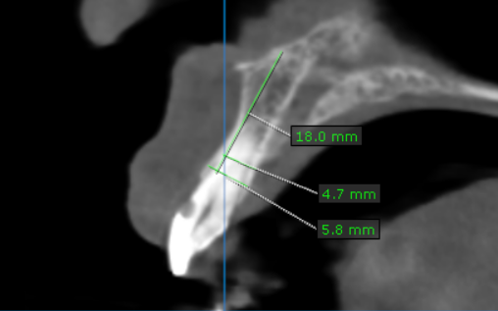
12 region | 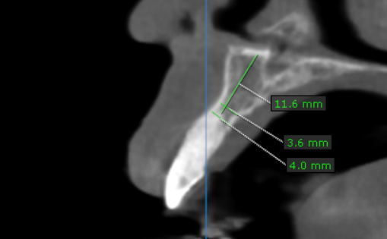
13 region | 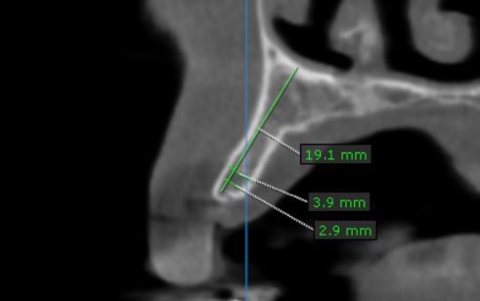
14 region | 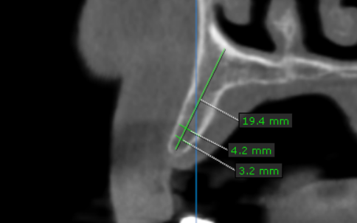
15 region | 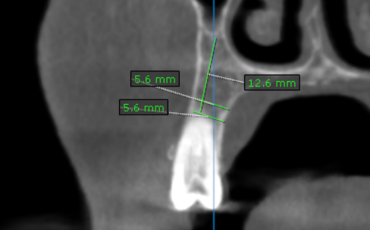
16 region | 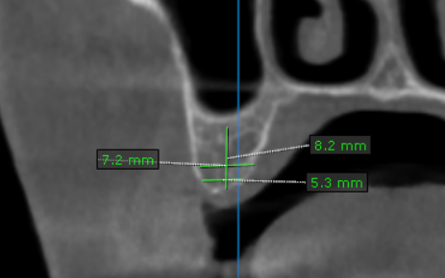
17 region | 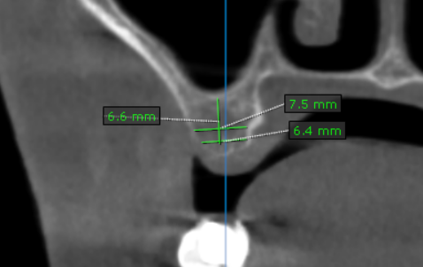
21 region | 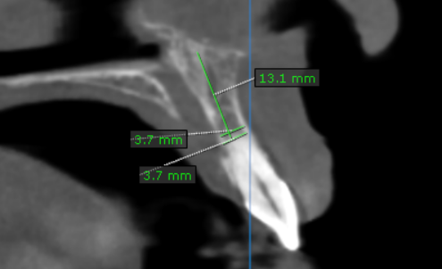
22 region | 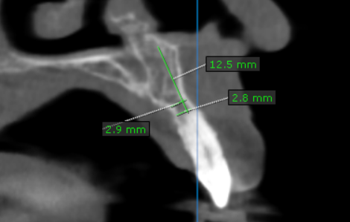
23 region | 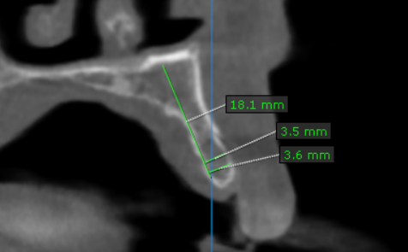
24 region | 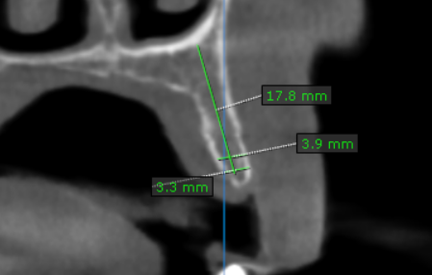
25 region | 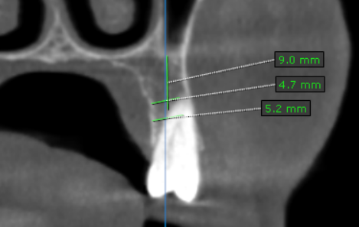
26 region | 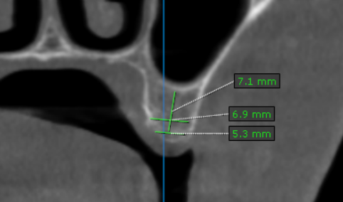
27 region | 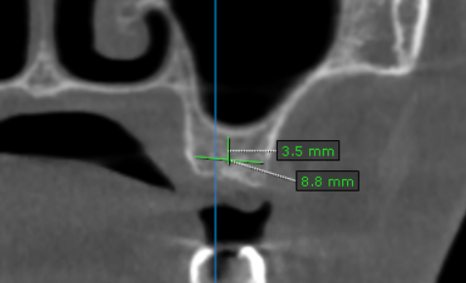
31 region | 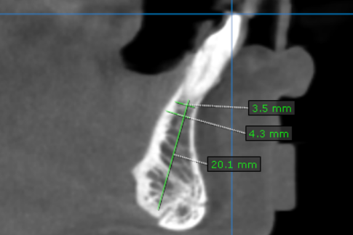
32 region | 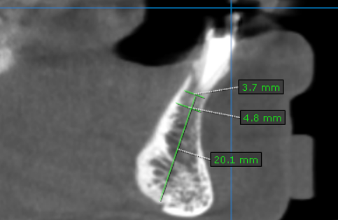
33 region | 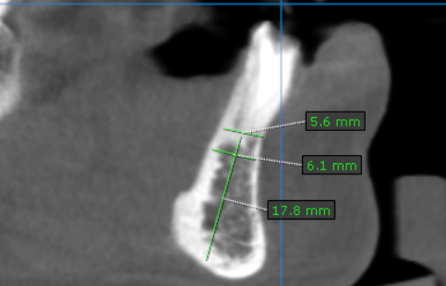
34 region | 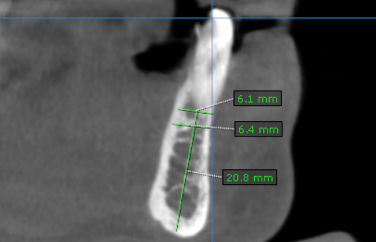
35 region | 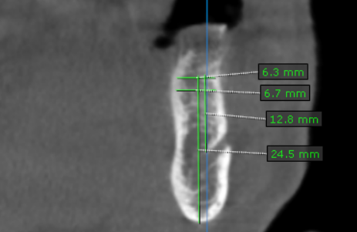
36 region | 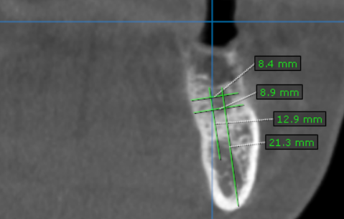
37 region | 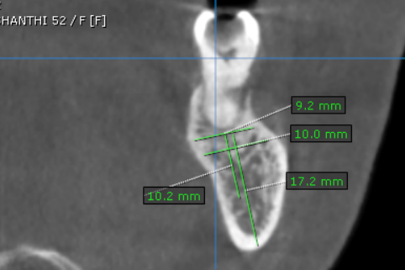
41 region | 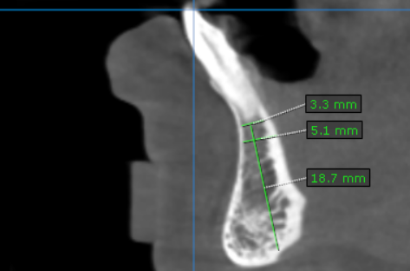
42 region | 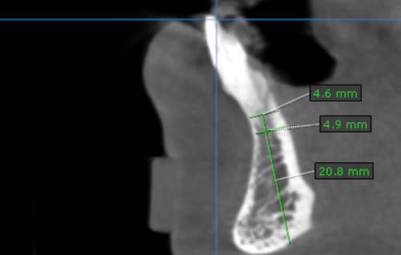
43 region | 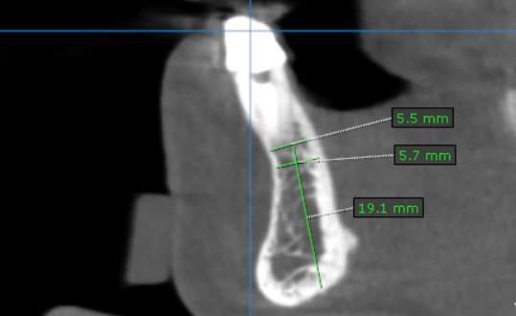
44 region | 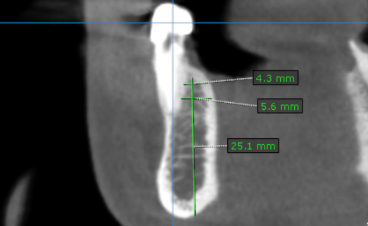
45 region | 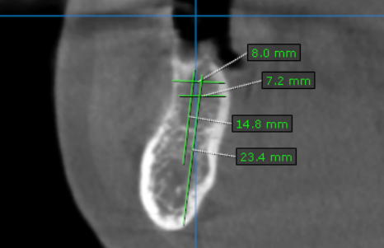
46 region | 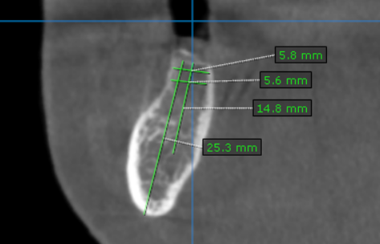
47 region | 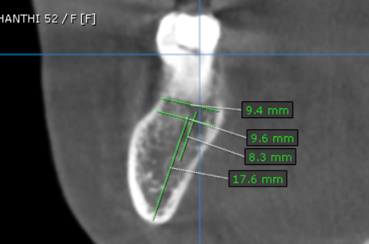

**** End of report ****

